Disk partitioning , file system creation, management and mounting

Launch virtual machine in the cloud , attach 20 GB EBS volume

1.Create 2 primary partitions of 3 GB each

primary partitions

The original partitioning scheme for PC hard disks allowed only four partitions, called primary partitions.

Logical partitions

To create more than four partitions, one of these four partitions can be divided into many smaller partitions, called logical partitions.

# fdisk /dev/sdb

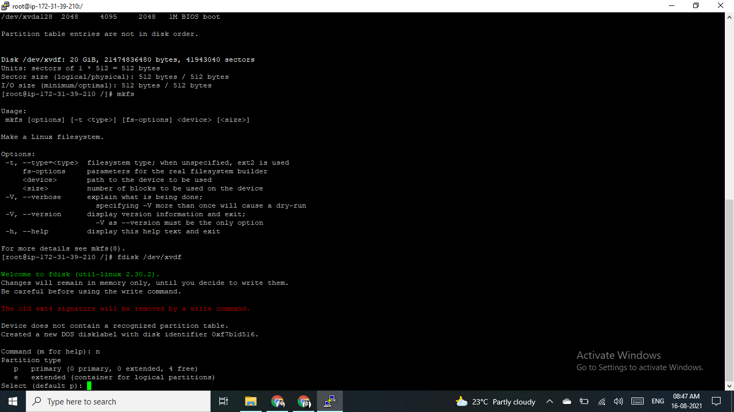

2. Create 2 logical partitions of 6 GB each

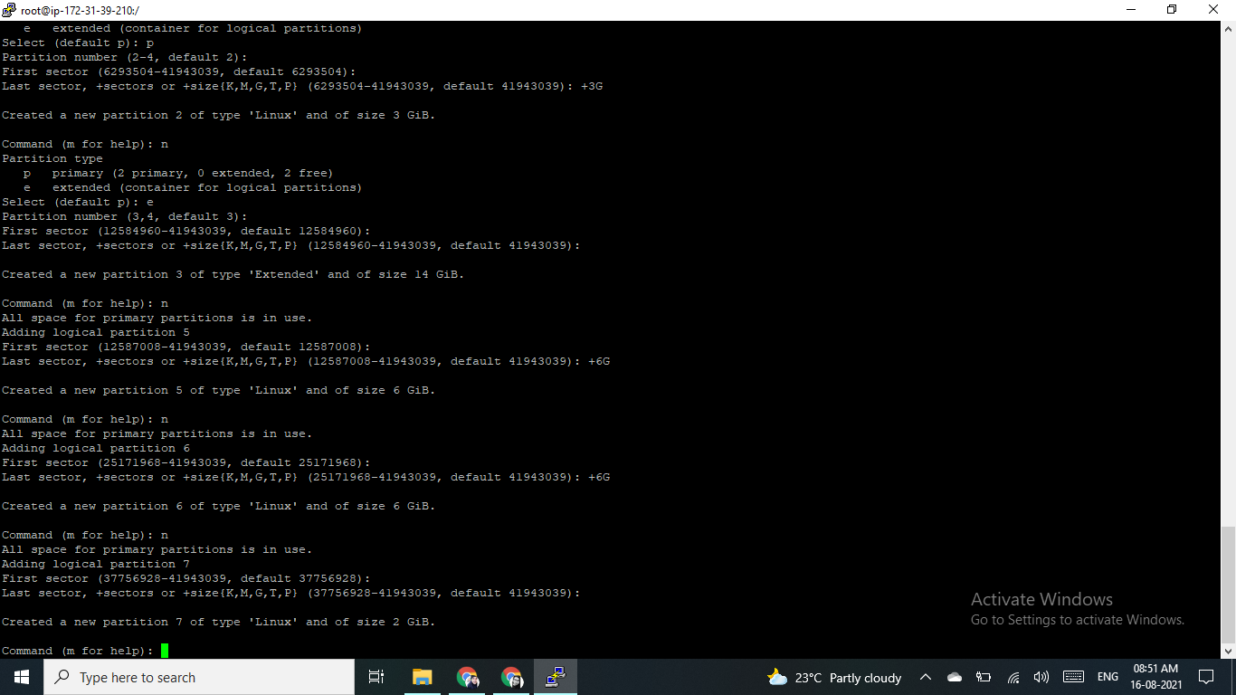

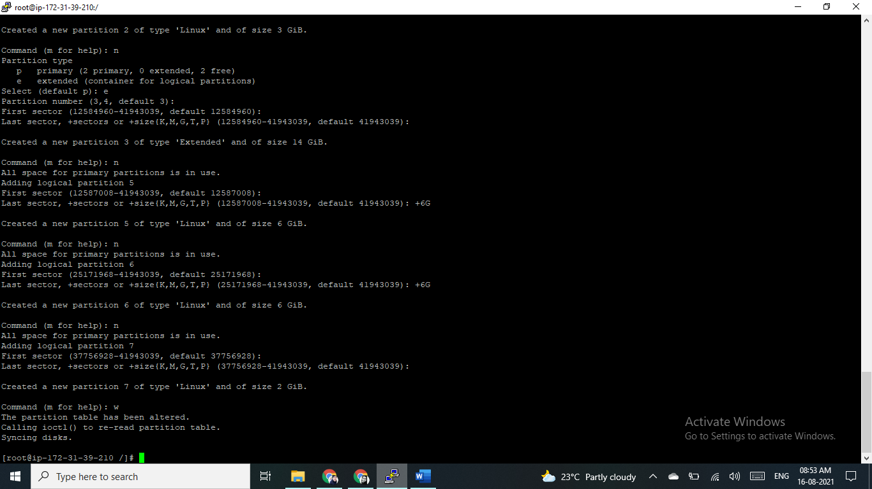

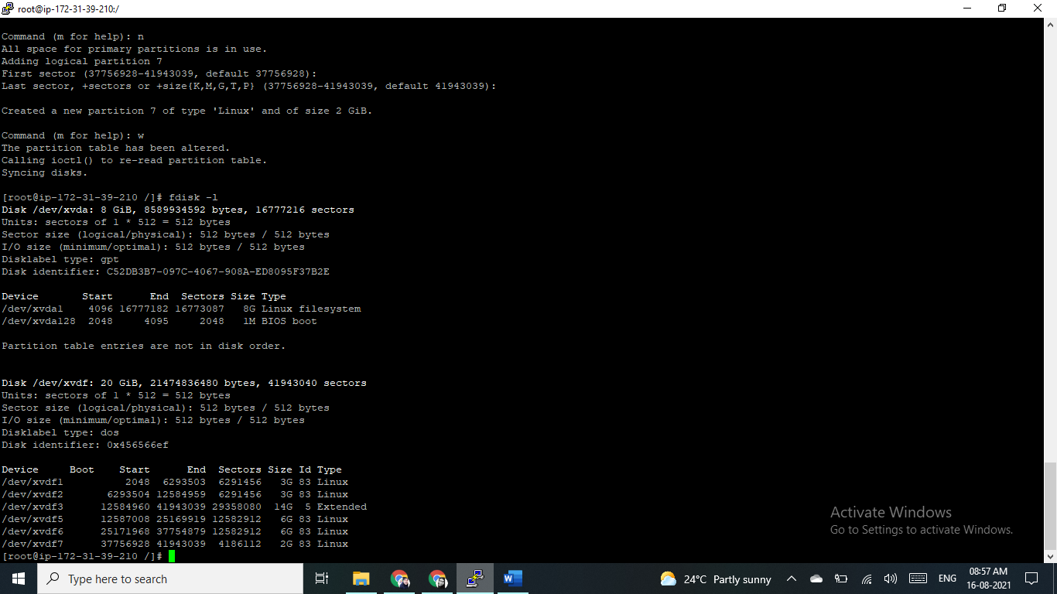

3.Format all 4 partitions and create ext4 filesystem on that

To format Linux partitions using ext4 on the new disk:

Disk1

# mkfs -t ext4 /dev/xvdb1

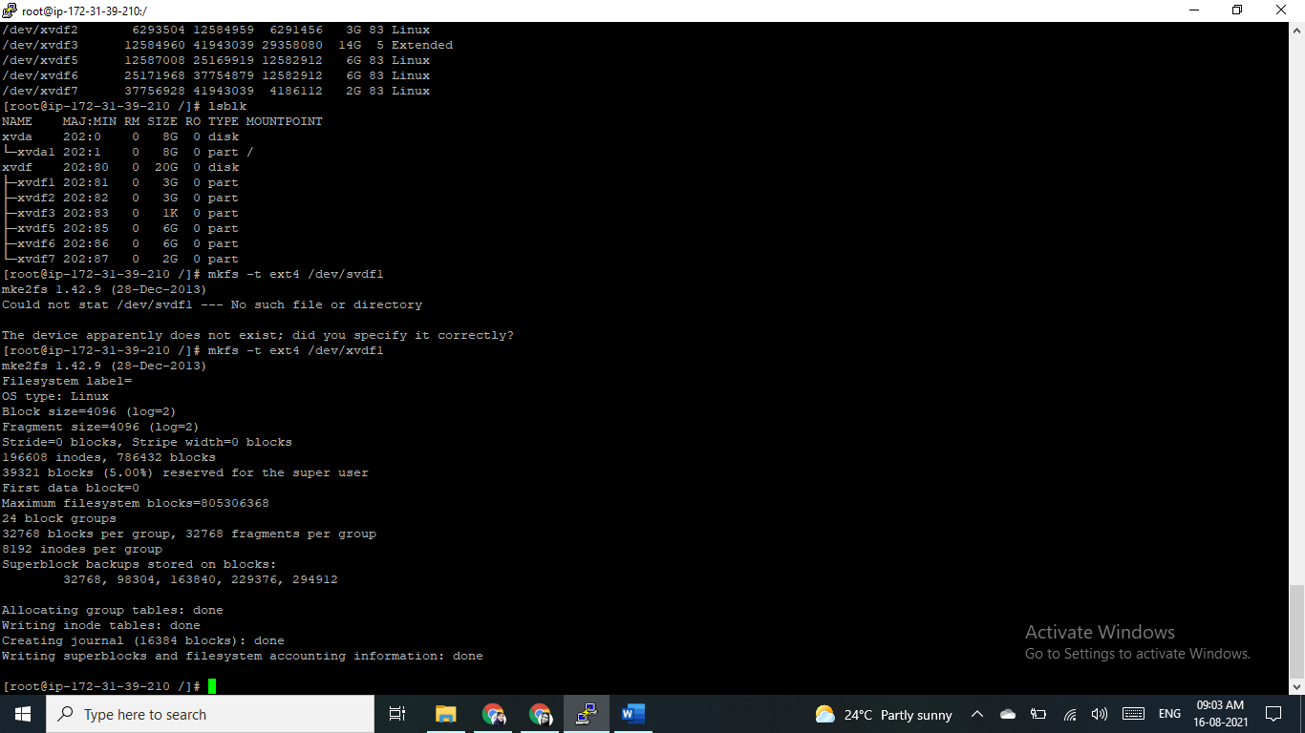

Disk2

# mkfs-t ext4 /dev/xvdb2

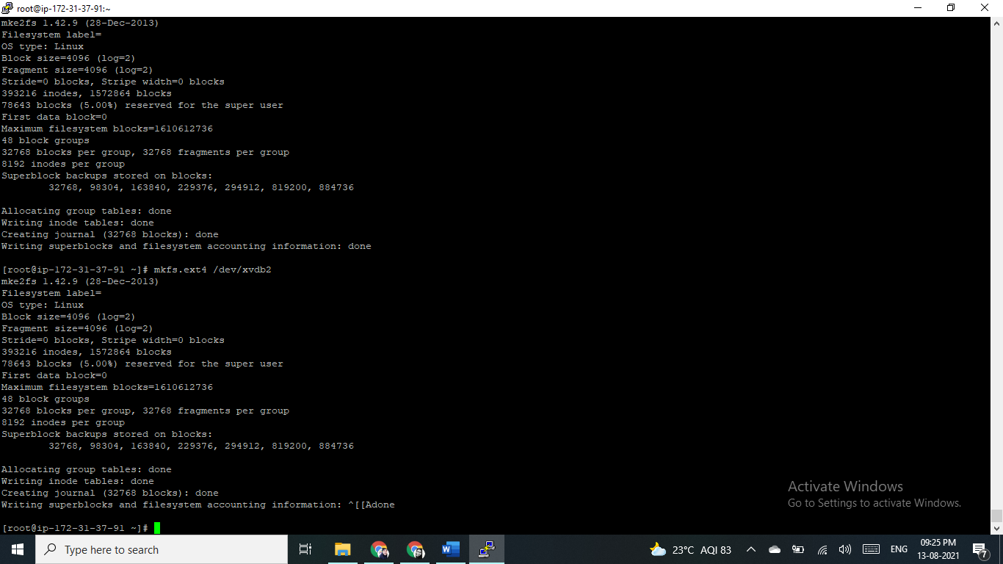

Disk3

# mkfs-t ext4 /dev/xvdb3

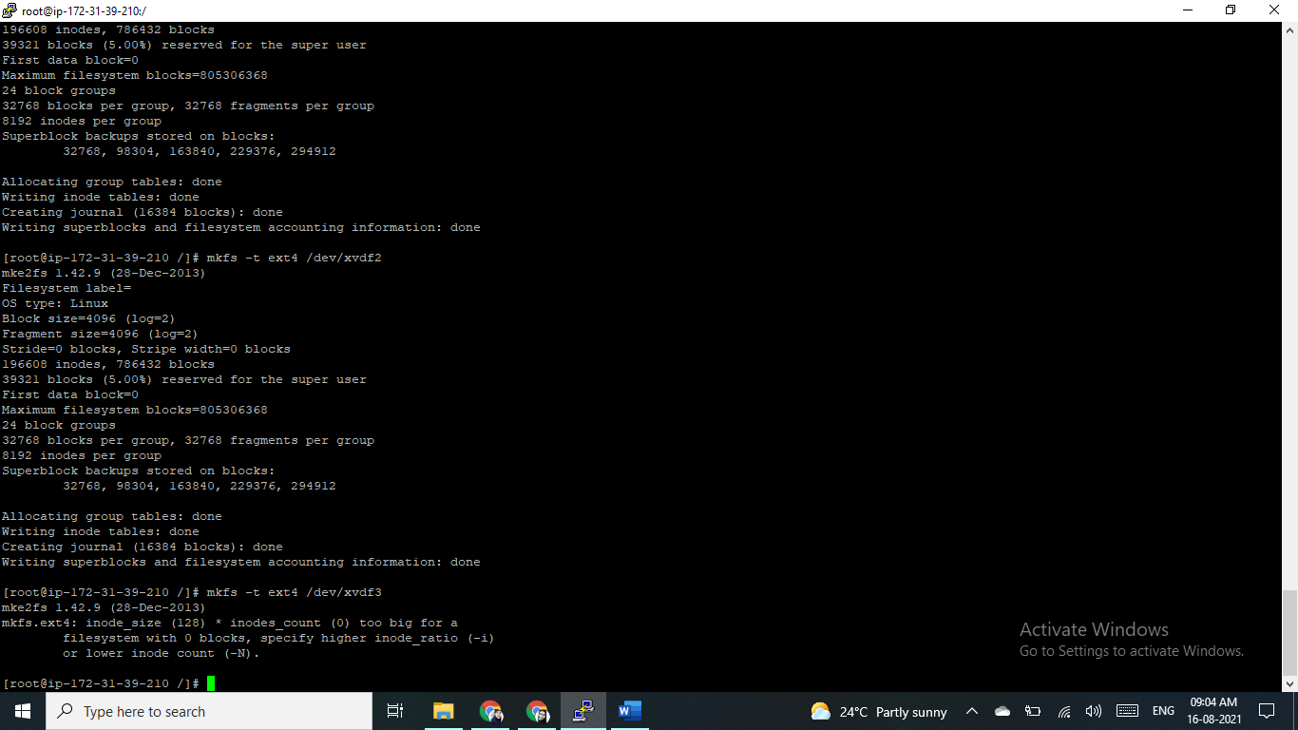

Disk3

# mkfs -t ext4 /dev/xvdb4

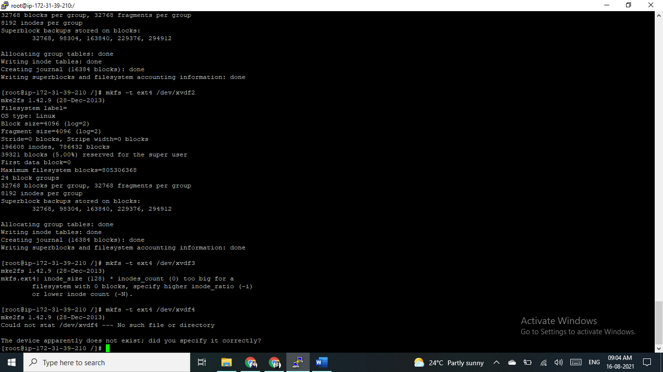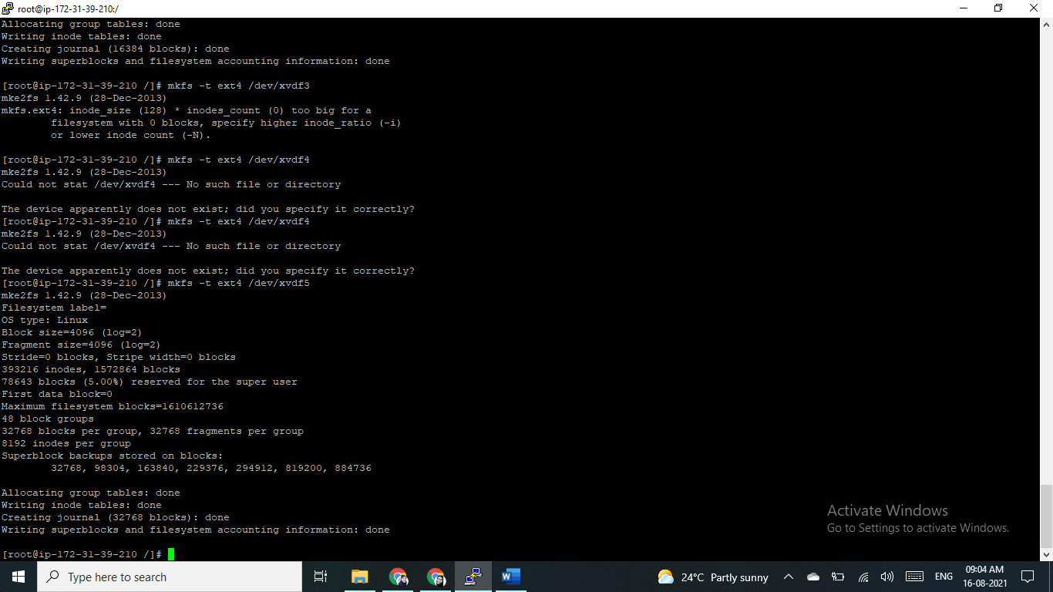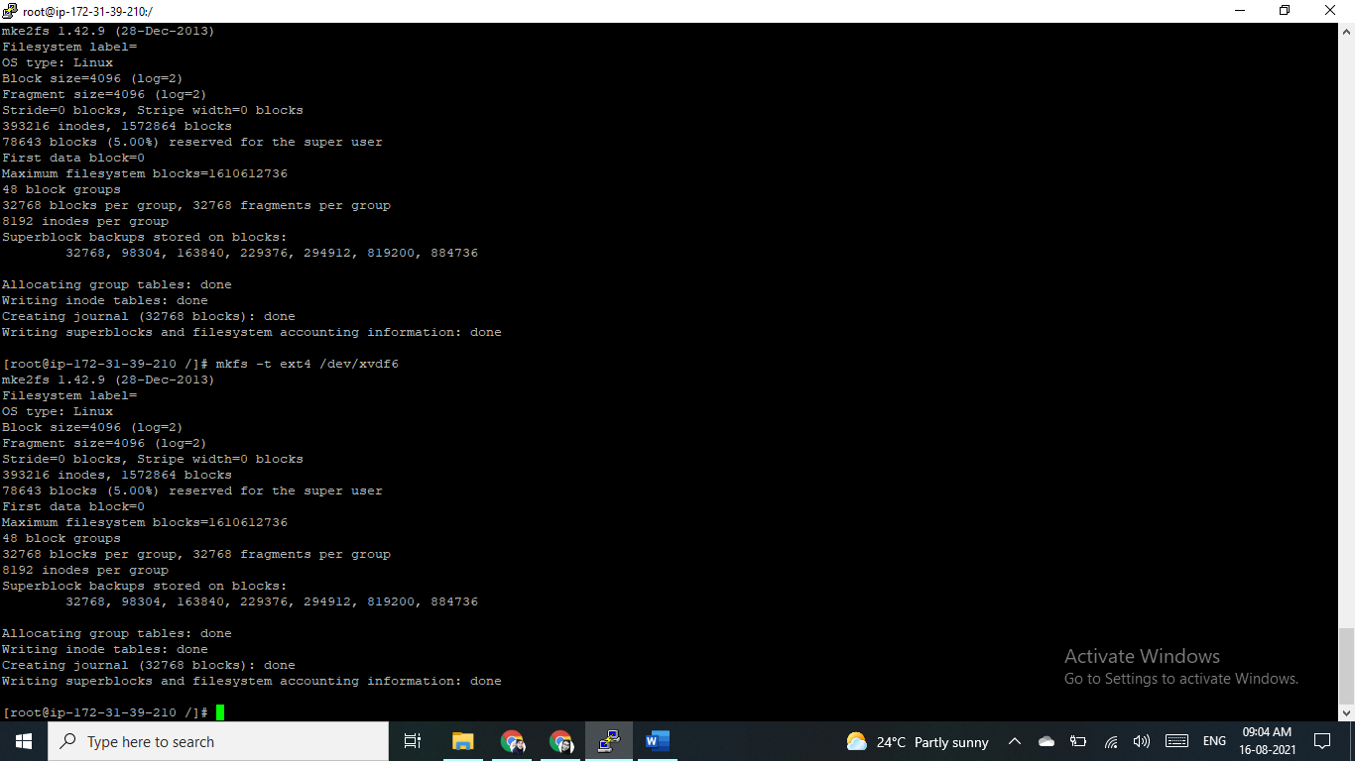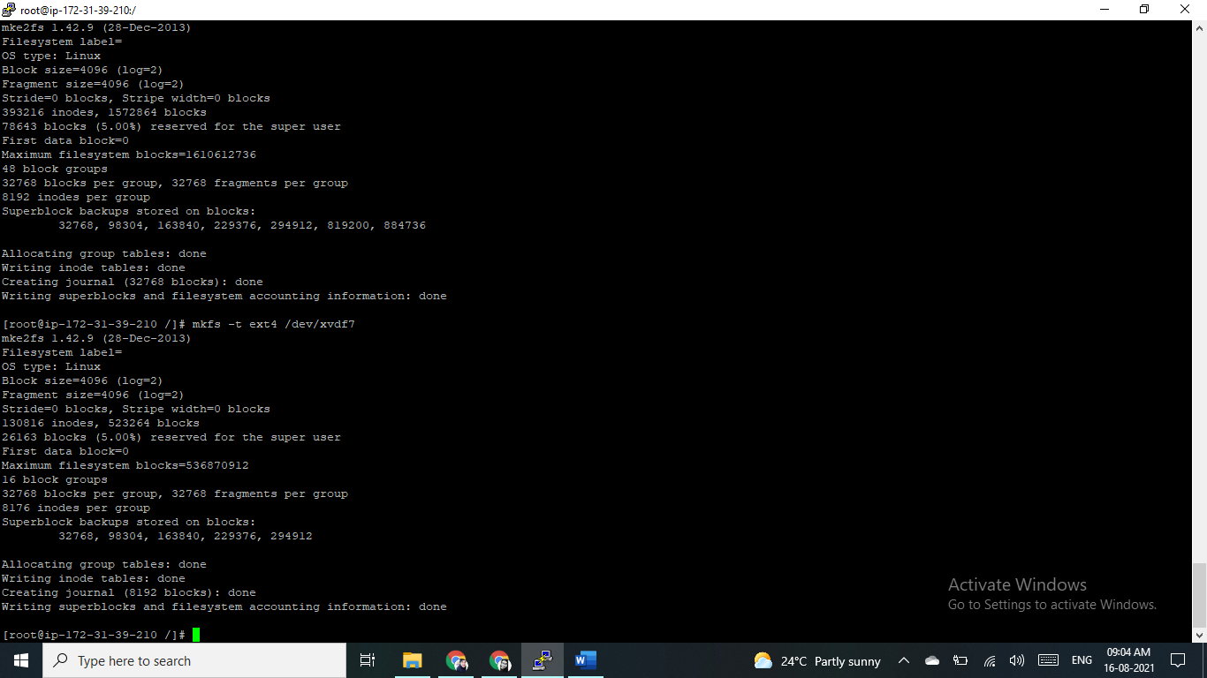

4. Create 4 folders inside root ( / ) folder name it as Data1, Data2, Data3, Data4.

# mkdir Data1

# mkdir Data2

# mkdir Data3

# mkdir Data4

5. Mount all formated partitions on the respective folders

# mount /dev/xvdf1 /Disk1

# mount /dev/xvdf2 /Disk2

# mount /dev/xvdf5 /Disk3

# mount /dev/xvdf6 /Disk4

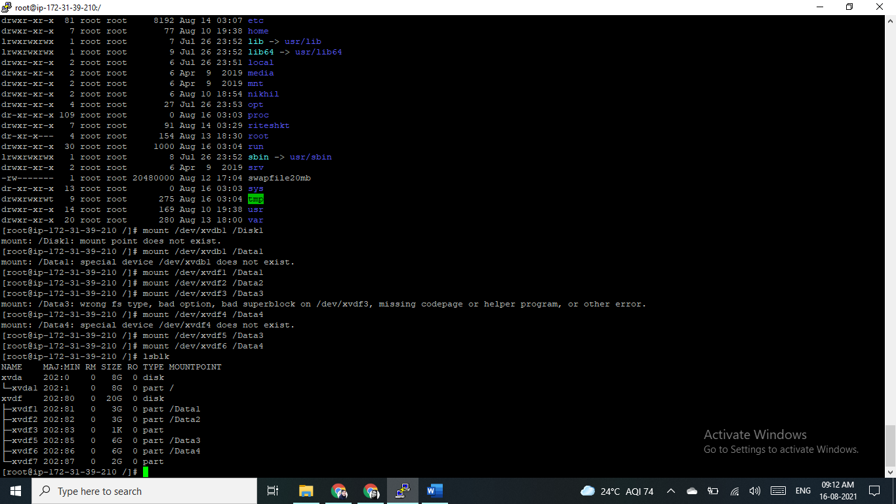

6.Create empty file inside each folders of size 2 GB, 2GB, and 4 GB, 4GB respectively  using  command -  dd - "convert and copy a file"

[root@ip-172-31-37-91 Data1]# truncate -s 2G file.txt

[root@ip-172-31-37-91 Data2]# truncate -s 2G file.txt

[root@ip-172-31-37-91 Data3]# truncate -s 4G file.txt

[root@ip-172-31-37-91 Data4]# truncate -s 4G file.txt

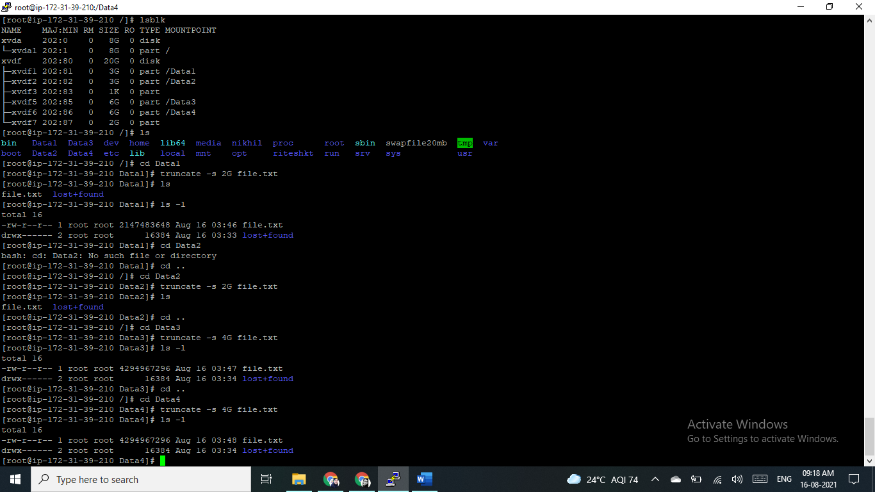

7.Go inside /Data1  and run  command -  while(true); do sleep 5s; done  , do ctrl-z

[root@ip-172-31-37-91 Disk1]# while(true); do sleep 5s; done

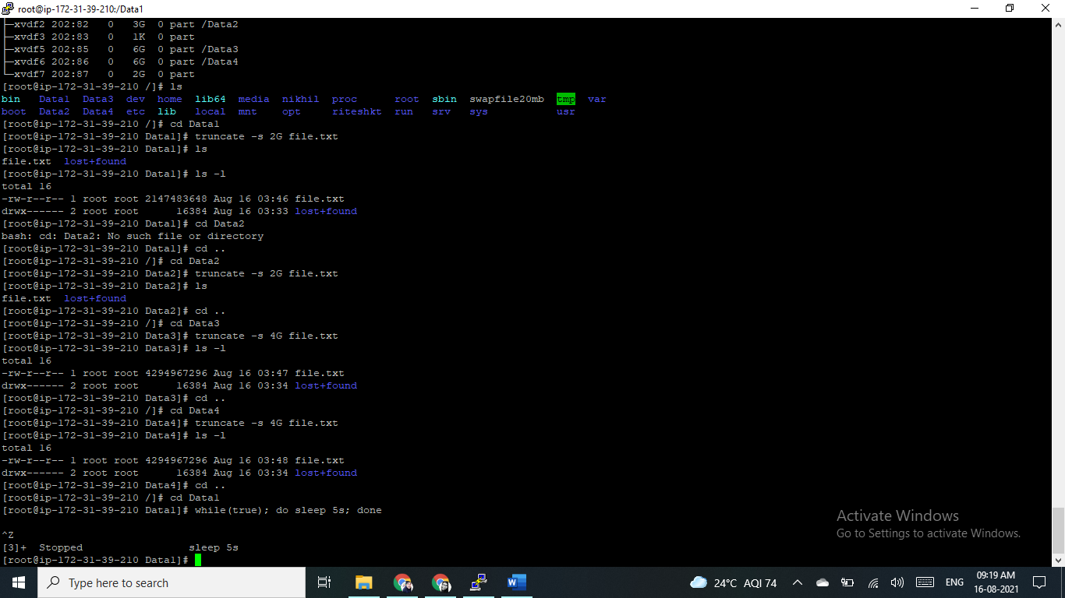

8.Check disk utilization of each mount point

**Linux command to check disk space using:**

1. df command – Shows the amount of disk space used and available on Linux file systems.
2. du command – Display the amount of disk space used by the specified files and for each subdirectory.
3. btrfs fi df /device/ – Show disk space usage information for a btrfs based mount point/file system.

df

df -H

df /Disk1

df /Disk2

df /Disk3

df –o

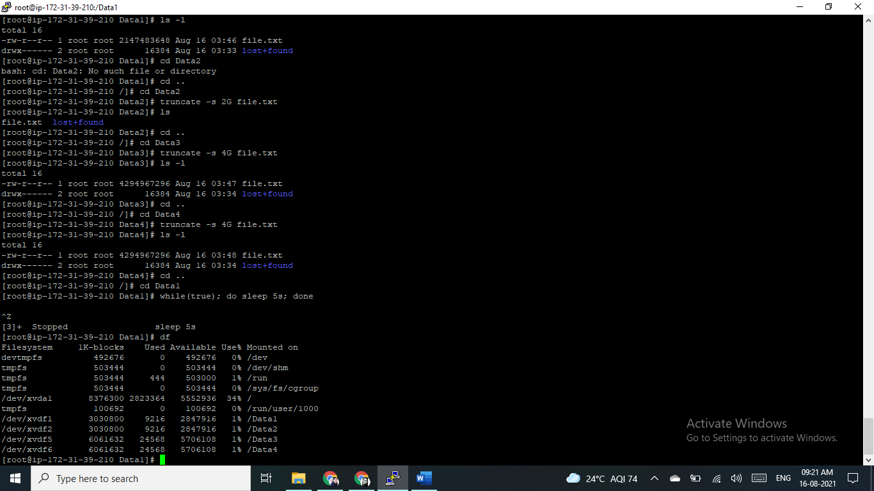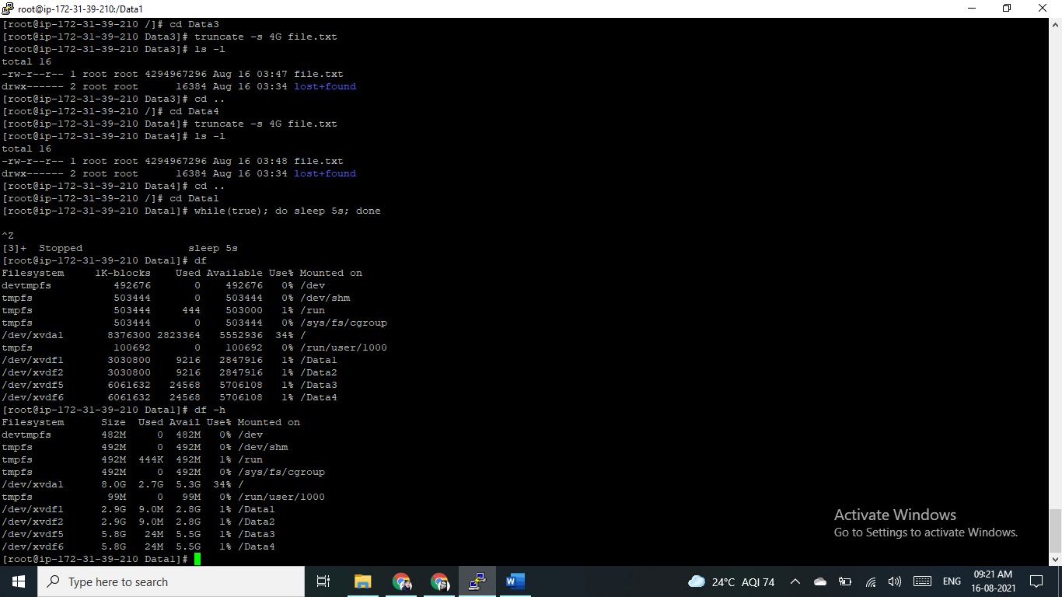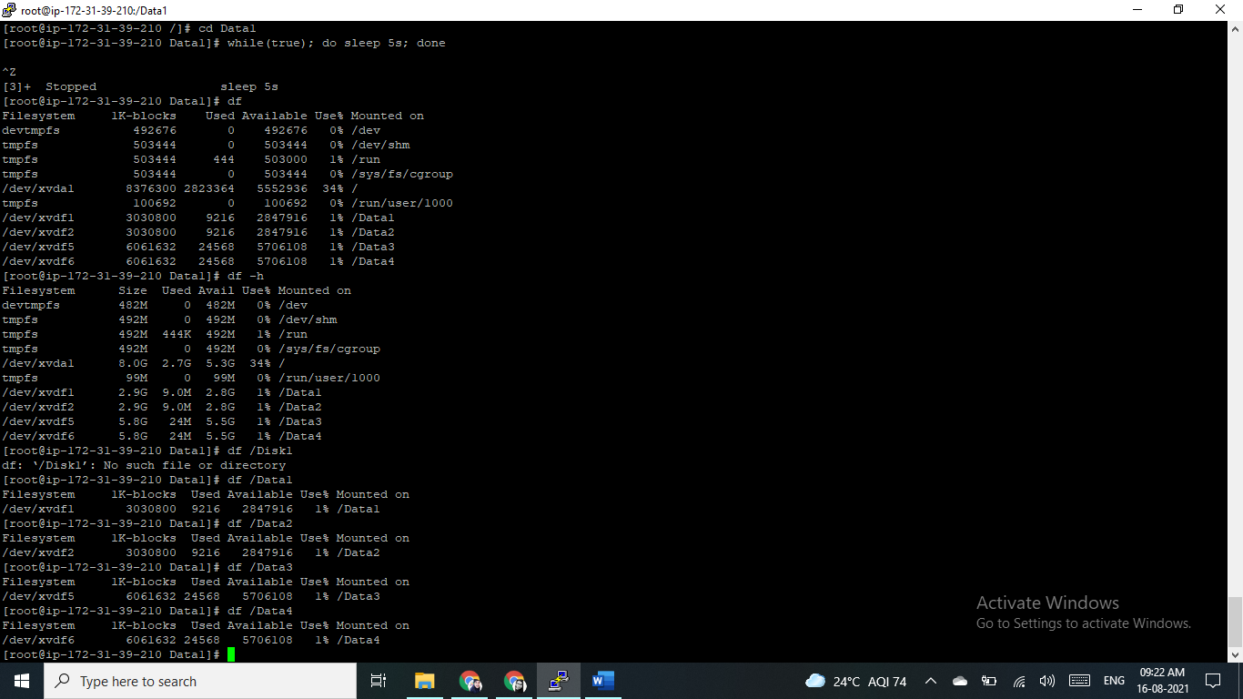

9.Unmount all partitions /Data1, /Data2, /Data3, /Data4

Umount /Data1

[root@ip-172-31-39-210 /]# umount -f Data1

umount: /Data1: target is busy.

[root@ip-172-31-39-210 /]# umount -l Data1

Umount /Data2

Umount /Data3

Umount /Data4

